Lab 03 - Newton’s Laws of Motion
NAME:________________
Time Spent on Lab = approximately two hours, does not need to be done at one sitting

Materials:
Larger salad bowl, bucket, or similar
Plastic wrap/Cling Wrap
A short/squat cup with roughly one liter capacity
A measuring cup

Learning Objectives:
- Define Newton’s Laws of Motion and give examples of their application
- Use Newton’s second law of motion to predict a resultant force vector
- Apply the sum of all forces on an object to predict the object’s acceleration

Description:
This week we will be exploring Newton’s three laws of motion. They will seem deceptively easy at first, so pay close attention to the details of what the questions are asking, in order to avoid over-simplifying a problem. The reason we study laws of motion that are over 300 years old, is that they work … most of the time! These laws are more than enough to send objects to the moon, and beyond! Of more pertinence to most students, these laws help medical practitioners apply holistic, non-invasive treatments for those who suffer from back pain, for instance. They are useful for the treatment of vehicle collision patients. They are used as the foundation for most every modern technology we use today. Essentially, they are rather important!

Activity #1 - Newton’s First Law:
An object at rest, stays at rest, unless acted upon by an unbalanced force. If you have not heard this expression, well, you have now! It is a part of Newton’s First Law of Motion that we will investigate in this activity. Simply put, if you do not push or pull an object, then it will not accelerate. Seems simple enough, but let’s see if we can “break” Newton’s First Law.
- Write down an example in your every-day life that you believe follows Newton’s First Law of Motion. Explain as precisely as possible why you think the example obeys the first law.

When a driver is driving a car at very high speed, and accidentally hit a wall or something like a tree, the vehicle will come to rest, but the driver will keep moving forward. This is the reason why the cars have a safety belt to avoid individuals from smashing into the screen. The example obeys Newton's First Law of motion because the moving car will not change its speed or direction unless acted upon by an external force.

Experiment:
- Start by getting a rather large bowl or bucket.
- Then place plastic wrap, cling film, across the top, so that it covers the entire opening. You may need two pieces overlapping a bit, to cover the entire opening.
- Try to make the plastic wrap as smooth as possible, though the darn stuff sticks to everything, including hands!!
- Place a light, short cup on top of the plastic wrap. A sketch of how it should be set up is below:
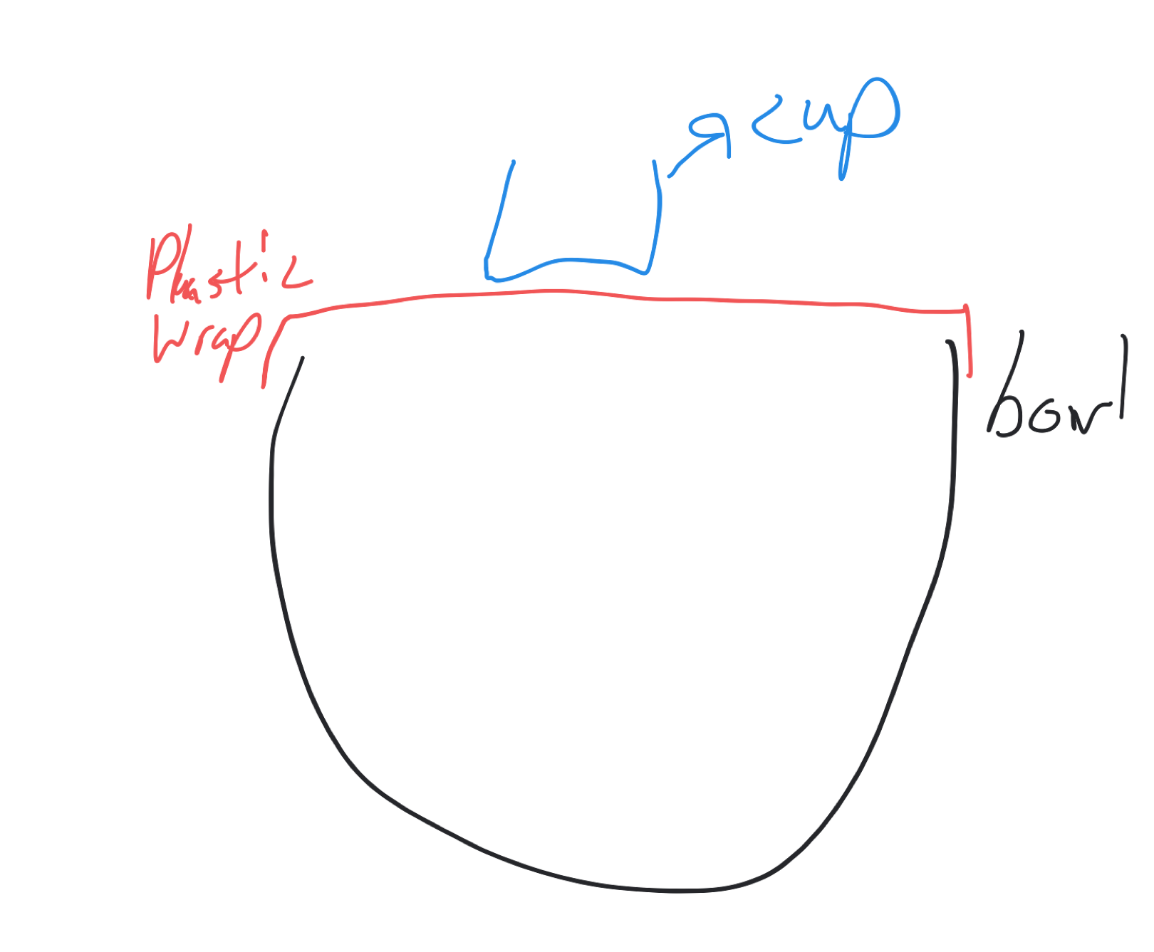
- Measure out 100 mL of water in a measuring cup and SLOWLY pour that into the cup on the plastic wrap.
- If the plastic wrap has not broken, then record this observation, and continue to add 100 milliliters of water, until the plastic wrap breaks or slides off the rim of the big bowl. Each time you add water, make note of whether the plastic breaks or not.
  - Example: 100ml - not broken
200ml - broken

2. Sketch out a free body diagram for the light cup, for each time you added 100 milliliters of water. Make sure that each sketch has the force vectors to scale, relative to each sketch. The last sketch, for when the plastic breaks, will have to be an abstraction of the forces RIGHT before the cup fell through the plastic.

plastic wrap 100 ml of water

bowl

Tensional force
Gravitational force

200ml of water

stretched plastic wrap

bowl

tensional force

gravitational force

300ml liters of water
Breaked plastic wrap

Bowl

Gravitational force

3. Do you think Newton’s First Law was obeyed in each instance? Justify this belief with a statement describing how the law applied to the measurements where the cup was stable, and a separate statement that describes the relation to the law when the plastic breaks.

Yes, Newton's First Law was obeyed because the cup was stable when equal water was added. The cup was stable because the cup water was equal to the strength of the plastic when additional water was added the plastic breaks because the other force excided the force of the plastic.

4. Review your example of Newton’s First Law of Motion in your life in Question #1, and explain if this example fits your current understanding of the law. Modify your example and explanation if it does not.

The example fits my current understanding of the law because if the vehicles don't have safety belt in case of an accident, the people will smash out through the windscreen thus causing more damage and death of people.

Activity #2 - Newton’s Second Law

Newton’s Second Law of Motion will seem to be the easiest of them all, it is just math!! The net force on any object is the product of the object’s mass times the acceleration, or in mathematical form, F = m*a. Easy enough!

Below is a data table of the reading of a spring force scale in newtons, as more mass is added to it.

Mass (kg) | Force (N)
0.1 | 0.99
0.2 | 2.0
0.3 | 3.1
0.4 | 3.8
0.5 | 5
0.6 | 5.8
0.7 | 7.2
0.8 | 8.0
0.9 | 8.9
1 | 10.1

2. Create a graph of Force versus Mass in a spreadsheet software of your choice. Be sure to include a best fit line through the data and the related equation. Paste this graph in the space below.

3. The slope of the best fit line may look familiar to you. Or at least it is close to a number you have used in homework and tests. Explain the physical significance of the slope and how it relates to Newton’s Second Law of motion.

The slope of the line represents the density of the spring. The slope shows the density of the spring if the density is high; the strength of the spring is also high. The example relates to Newton's Second Law of motion because the increase in weight cause the force to increase.

4. Below is a set of NEW mass and force data, only the force values are noticeably different. Replot the data in a graph of Force versus Mass. Fit a best fit line to the data and display the equation of that line. Put that graph in the space below.

Mass (kg) | Force (N)
0.1 | 2.4
0.2 | 5.1
0.3 | 7.3
0.4 | 10.0
0.5 | 12.4
0.6 | 15.3
0.7 | 17.2
0.8 | 20.2
0.9 | 22.44
1 | 25.11

5. The slope of your line has a very important physical significance, similar to that in question #3. Write out your interpretation of the slope and explain why it is so different than #3. Come up with two unique scenarios that would explain the data, which do not involve error in the measurements.

The slope of the two experiments is different because the densities of the spring are different. The first experiment the spring has high density since the changes in the force with mass is small compared to the second experiment where the changes are significant. This means that the second experiment the spring is not strong to hold large mass because of its density.

6. Hopefully at least one of your explanations involved the scale moving. How do you justify the results via Newton’s Second Law of Motion? HINT: Think about riding a rollercoaster or elevator upwards!

When one stand on a scale, the scales reading is the measure of the weight of the person. If an elevator moving upward is stopped, the scale reads the weight of the person and the weight of the lift. When the elevator is moving at constant speed, the elevator is in equilibrium, and when the elevator increases the velocity, the weight changes and the person feels heavier.

7. Now that you have a better idea of how forces are evident in daily life, take a look at your semester long video project. Only now, think of how forces are involved in your video. Firstly, write out a list of these forces. Secondly, develop a question that relates to these forces.

List of the forces.
    - Applied force
    - Frictional force
    - Normal force
    - Centrifugal force
What are the forces that are involved when a person is stirring a mug of coffee using a spoon?
When a mug of coffee is poured inside a cup it extend a normal forces between the surfaces of the coffee and the cup. When applying force to stir the coffee it lead to centrifugal forces. As a result frictional force between the surface of cup and the coffee is generated that minimize the coffee motion near the cup surface.

Please download this document as a PDF. Then upload this PDF to
Blackboard under the assignment “Lab 03”, for grading.

